**Create Account:**

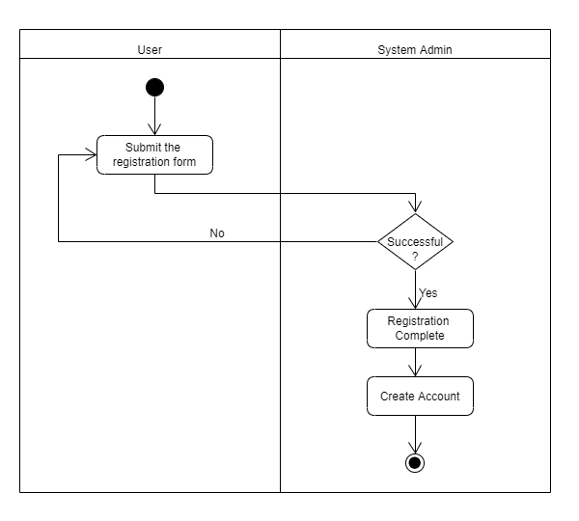

|  |  |  |  |  |  |
| --- | --- | --- | --- | --- | --- |
| Step ID | Process Step  (activity/Decision) | Who/What Performs Step | Parallel Activity | Loop | Preceding Step |
| 1 | Submit the registration form | User | No | Yes | - |
| 2 | Decision: Successful? | System Admin | No | Yes | 1 |
| 3 | Registration Complete | System Admin | No | Yes | 2 |
| 4 | Create Account | System Admin | No | No | 3 |

**Access Profile:**

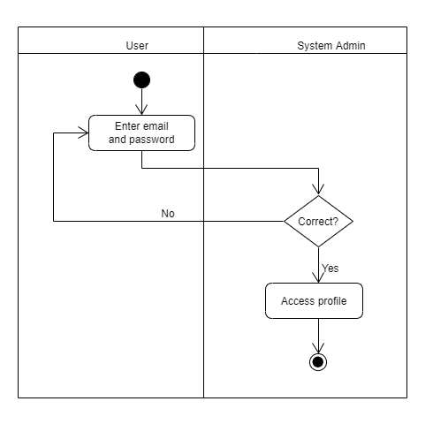

|  |  |  |  |  |  |
| --- | --- | --- | --- | --- | --- |
| Step ID | Process Step  (activity/Decision) | Who/What Performs Step | Parallel Activity | Loop | Preceding Step |
| 1 | Enter email and password | User | No | Yes | - |
| 2 | Decision: Correct? | System Admin | No | Yes | 1 |
| 3 | Access Profile | System Admin | No | Yes | 2 |

**Find Job:**

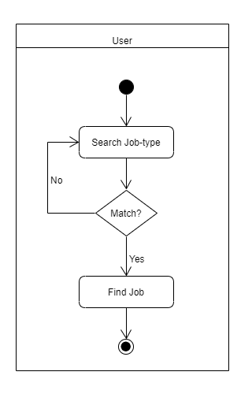

|  |  |  |  |  |  |
| --- | --- | --- | --- | --- | --- |
| Step ID | Process Step  (activity/Decision) | Who/What Performs Step | Parallel Activity | Loop | Preceding Step |
| 1 | Search Job-type | User | No | Yes | - |
| 2 | Decision: Match? | User | No | Yes | 1 |
| 3 | Find Job | User | No | Yes | 2 |

**Find Courses:**

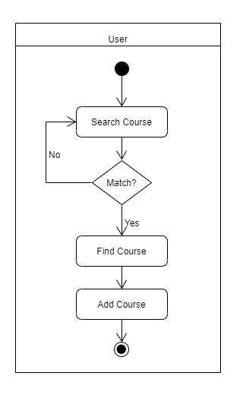

|  |  |  |  |  |  |
| --- | --- | --- | --- | --- | --- |
| Step ID | Process Step  (activity/Decision) | Who/What Performs Step | Parallel Activity | Loop | Preceding Step |
| 1 | Search Course | User | No | Yes | - |
| 2 | Decision: Match? | User | No | Yes | 1 |
| 3 | Find Course | User | No | Yes | 2 |
| 4 | Add Course | User | No | No | 3 |

**Make Payment:**

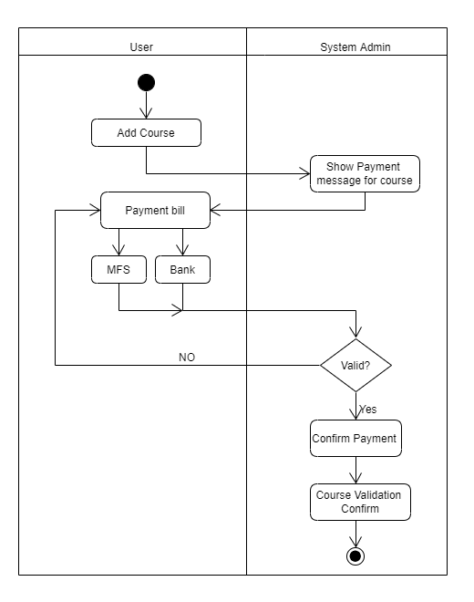

|  |  |  |  |  |  |
| --- | --- | --- | --- | --- | --- |
| Step ID | Process Step  (activity/Decision) | Who/What Performs Step | Parallel Activity | Loop | Preceding Step |
| 1 | Add Course | User | No | No | - |
| 2 | Show Payment Message for Course | System Admin | No | No | 1 |
| 3 | Payment Bill | User | No | No | 2 |
| 4 | MFS | User | No | Yes | 3 |
| 5 | Bank | User | No | Yes | 3 |
| 6 | Decision: Valid? | System Admin | No | Yes | 4,5 |
| 7 | Confirm Payment | System Admin | No | Yes | 6 |
| 8 | Course Validation Confirm | System Admin | No | No | 7 |